

design & Implement   
A rgb led control

Youssef Abbas

Arafa Arafa



Sprints

Contents

Project Introduction: 1

Hardware Requirements: 1

Software Requirements: 1

High Level Design: 2

Layered architecture: 2

Module Description 3

Driver Documentations 4

Button 4

LED 5

GPIO 6

Low Level Design: 8

Flowchart 8

LED 8

BUTTON 12

GPIO 14

APPLICATION 19

Figure 1 led_initialization 8

Figure 2 led_turn_on 9

Figure 3 led_turn_off 10

Figure 4 led_toggle 11

Figure 5 button_initialization 12

Figure 6 button_read_state 13

Figure 7 dio_enable_clock 14

Figure 8 dio_enable_clock 15

Figure 9 dio_set_pin 16

Figure 10 dio_toggle_pin 17

Figure 11 dio_read_pin 18

# Project Introduction:

The RGB LED Control System is a hardware and software solution designed to control the behavior of an RGB LED based on user interaction with a button. The system utilizes the TivaC board as the target hardware platform and provides an intuitive interface for users to switch between different LED colors and states.

## Hardware Requirements:

* TivaC board: The system is implemented on the TivaC development board, which serves as the main hardware platform.
* SW1 Button: The SW1 button is used as an input button to trigger LED state changes.
* RGB LED: The system controls an RGB LED, allowing for various color combinations and lighting effects.

## Software Requirements:

* Initialization: The system initializes by setting up the necessary configurations, including GPIO pins, interrupts, and timers.
* RGB LED Control: The RGB LED is initially turned off. Each press of the SW1 button results in a different LED state change, following a specific sequence:
  1. First press: The Red LED turns on.
  2. Second press: The Green LED turns on.
  3. Third press: The Blue LED turns on.
  4. Fourth press: All LEDs (Red, Green, and Blue) turn on simultaneously.
  5. Fifth press: All LEDs are turned off.
  6. Sixth press: The sequence repeats from the beginning.
* Button Driver: The Button driver detects button presses and triggers the corresponding LED state changes.
* GPIO Driver: The GPIO driver handles the configuration and control of GPIO pins to interface with the RGB LED.
* LED Driver: The LED driver provides functions to set the state of individual LEDs (Red, Green, and Blue) and control the RGB LED's behavior.

# High Level Design:

## Layered architecture:

1. Application
2. ECUAL
3. MCAL
4. Microcontroller

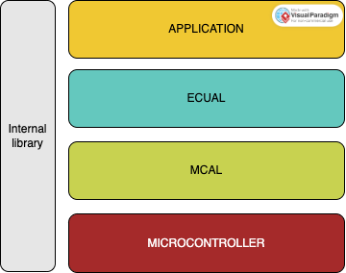

## Module Description

1. Application
2. ECUAL
   1. LED
   2. Button
3. MCAL
   1. DIO
   2. SYSTICK
4. Microcontroller

## Driver Documentations

## Button

**Module Description** The push button module provides functions for initializing a push button, reading its state, and configuring its properties. It utilizes the DIO (Digital Input/Output) module for pin configuration and manipulation.

**Macro Declarations** No macro declarations are included in the provided code.

**Macro Function Declarations** No macro function declarations are included in the provided code.

**Data Types Declarations**

* **btn_enu_btn_state_t**: An enumerated type representing the possible states of the button. It has two values: BUTTON_RELEASED and BUTTON_PRESSED.
* **btn_enu__btn_active_t**: An enumerated type representing the active state of the button. It has two values: BUTTON_ACTIVE_LOW and BUTTON_ACTIVE_HIGH.
* **button_str_btn_config_t**: A structure representing the configuration of the button. It contains the following members:
  + **port_name**: An instance of the **dio_enu_portx_t** enum, representing the port name of the button pin.
  + **pin**: An instance of the **dio_enu_pinx_t** enum, representing the pin number of the button.
  + **button_state**: An instance of the **btn_enu_btn_state_t** enum, representing the initial state of the button.
  + **button_active**: An instance of the **btn_enu__btn_active_t** enum, representing the active state of the button.

**Function Declarations**

* **button_initializa**: Initializes the push button by configuring its pin and setting the initial state. It takes a pointer to a **button_str_btn_config_t** structure as an argument. Returns a value of type **brn_enu_return_state_t** indicating the success or failure of the initialization.
* **button_read_state**: Reads the state of the push button and updates the **btn_enu_btn_state_t** variable pointed to by **ptr_enu_btn_state**. It takes a pointer to a **button_str_btn_config_t** structure and a pointer to a **btn_enu_btn_state_t** variable as arguments. Returns a value of type **brn_enu_return_state_t** indicating the success or failure of reading the state.

## LED

The LED module provides functions for initializing an LED, turning it on and off, and toggling its state. It utilizes the DIO (Digital Input/Output) module for pin configuration and manipulation.

**Macro Declarations** No macro declarations are included in the provided code.

**Macro Function Declarations** No macro function declarations are included in the provided code.

**Data Types Declarations**

* **led_enu_status_t**: An enumerated type representing the possible states of the LED. It has two values: LED_OFF and LED_ON.
* **led_str_led_config_t**: A structure representing the configuration of the LED. It contains the following members:
  + **port_name**: An instance of the **dio_enu_portx_t** enum, representing the port name of the LED pin.
  + **pin**: An instance of the **dio_enu_pinx_t** enum, representing the pin number of the LED.
  + **led_status**: An instance of the **led_enu_status_t** enum, representing the initial state of the LED.

**Function Declarations**

* **led_initialization**: Initializes the LED by configuring its pin and setting the initial state. It takes a pointer to a **led_str_led_config_t** structure as an argument. Returns a value of type **led_enu_return_state_t** indicating the success or failure of the initialization.
* **led_turn_on**: Turns on the LED by setting the appropriate pin to the active state. It takes a pointer to a **led_str_led_config_t** structure as an argument. Returns a value of type **led_enu_return_state_t** indicating the success or failure of turning on the LED.
* **led_turn_off**: Turns off the LED by setting the appropriate pin to the inactive state. It takes a pointer to a **led_str_led_config_t** structure as an argument. Returns a value of type **led_enu_return_state_t** indicating the success or failure of turning off the LED.
* **led_toggle**: Toggles the state of the LED. If the LED is currently on, it will be turned off, and vice versa. It takes a pointer to a **led_str_led_config_t** structure as an argument. Returns a value of type **led_enu_return_state_t** indicating the success or failure of toggling the LED.

## GPIO

The DIO interface module provides functions and data types for configuring and manipulating digital input/output pins. It allows you to enable clock for a specific port, initialize pins, set pin states, toggle pin states, and read pin states.

**Data Types Declarations**

* **dio_enu_portx_t**: An enumerated type representing the available ports. It includes values from DIO_PORTA to DIO_PORTF, and MAX_INVALID_PORT.
* **dio_enu_pinx_t**: An enumerated type representing the available pins. It includes values from DIO_PIN_0 to DIO_PIN_7, and MAX_INVALID_PIN.
* **dio_enu_pin_state_t**: An enumerated type representing the possible states of a pin. It has two values: DIO_PIN_LOW_STATE and DIO_PIN_HIGH_STATE.
* **dio_enu_pin_mode_t**: An enumerated type representing the mode of a pin. It includes values DIO_PIN_INPUT, DIO_PIN_OUTPUT, DIO_PIN_AFM, and DIO_PIN_ANALOG.
* **dio_enu_output_type_t**: An enumerated type representing the output type of a pin. It includes values DIO_PIN_OUTPUT_PUSH_PULL and DIO_PIN_OUTPUT_OPEN_DRAIN.
* **dio_enu_output_current_t**: An enumerated type representing the output current of a pin. It includes values DIO_PIN_2MA, DIO_PIN_4MA, and DIO_PIN_8MA.
* **dio_str_output_type_and_speed_and_state_t**: A structure representing the output type, speed, and state of a pin. It contains the following members:
  + **enu_output_type**: An instance of the **dio_enu_output_type_t** enum, representing the output type of the pin.
  + **enu_output_current**: An instance of the **dio_enu_output_current_t** enum, representing the output current of the pin.
  + **enu_pin_state**: An instance of the **dio_enu_pin_state_t** enum, representing the initial state of the pin.
* **dio_enu_input_type_t**: An enumerated type representing the input type of a pin. It includes values DIO_PIN_INPUT_NO_PULL_UP_NO_PULL_DOWN, DIO_PIN_INPUT_PULL_UP, and DIO_PIN_INPUT_PULL_DOWN.
* **dio_un_input_output_type_t**: A union type representing either the input or output type of a pin. It contains the following members:
  + **str_output_type_and_speed_and_state**: An instance of the **dio_str_output_type_and_speed_and_state_t** structure representing the output type, speed, and state of the pin.
  + **enu_input_type**: An instance of the **dio_enu_input_type_t** enum representing the input type of the pin.
* **dio_str_pin_Config_t**: A structure representing the configuration of a pin. It contains the following members:
  + **enu_port**: An instance of the **dio_enu_portx_t** enum, representing the port of the pin.
  + **enu_pin**: An instance of the **dio_enu_pinx_t** enum, representing the pin number.
  + **enu_pin_mode**: An instance of the **dio_enu_pin_mode_t** enum, representing the mode of the pin.
  + **un_input_output_type**: An instance of the **dio_un_input_output_type_t** union, representing either the input or output type of the pin.
* **dio_enu_return_state_t**: An enumerated type representing the return states of the DIO functions. It includes values DIO_NOT_OK, DIO_OK, DIO_NULL_PTR, and DIO_EXCEED_PORT.

**Function Declarations**

* **dio_enable_clock**: Enables the clock for a specific port. It takes a parameter of type **dio_enu_portx_t** representing the port number. Returns a value of type **dio_enu_return_state_t** indicating the success or failure of enabling the clock.
* **dio_init_pin**: Initializes a pin by configuring its mode, input/output type, and state. It takes a pointer to a **dio_str_pin_Config_t** structure as an argument. Returns a value of type **dio_enu_return_state_t** indicating the success or failure of pin initialization.
* **dio_set_pin**: Sets the state of a pin to either high or low. It takes a pointer to a **dio_str_pin_Config_t** structure and the desired pin state as arguments. Returns a value of type **dio_enu_return_state_t** indicating the success or failure of setting the pin state.
* **dio_toggle_pin**: Toggles the state of a pin. If the pin is currently high, it will be set to low, and vice versa. It takes a pointer to a **dio_str_pin_Config_t** structure as an argument. Returns a value of type **dio_enu_return_state_t** indicating the success or failure of toggling the pin state.
* **dio_read_pin**: Reads the current state of a pin and stores it in a variable. It takes a pointer to a **dio_str_pin_Config_t** structure and a pointer to a **dio_enu_pin_state_t** variable as arguments. Returns a value of type **dio_enu_return_state_t** indicating the success or failure of reading the pin state.

## systick

The SysTick interface provides functions for interacting with the SysTick timer. It allows configuring the timer, setting timeouts, enabling/disabling the counter, and retrieving the state of the timer. This module is designed to work with the SysTick timer available on microcontrollers.

Data Types:

* ptr_void_func: Function pointer type for callback functions.
* systick_enu_reach_zero_flag_t: Enumeration representing the reach-zero flag of the SysTick timer.
  + SYSTICK_NOT_REACH_FLAG: SysTick timer has not reached zero.
  + SYSTICK_REACH_FLAG: SysTick timer has reached zero.
* systick_enu_clock_source_t: Enumeration representing the clock source for the SysTick timer.
  + SYSTICK_PIOSC_CLOCK_PRE_4: PIOSC (Precision Internal Oscillator) clock divided by 4.
  + SYSTICK_SYSCLK_CLOCK: System clock.
* systick_enu_int_state_t: Enumeration representing the interrupt state for the SysTick timer.
  + SYSTICK_DISABLE_INT: Disable interrupts.
  + SYSTICK_ENABLE_INT: Enable interrupts.
* systick_enu_counter_state_t: Enumeration representing the counter state for the SysTick timer.
  + SYSTICK_DISABLE_COUNTER: Disable the SysTick counter.
  + SYSTICK_ENABLE_COUNTER: Enable the SysTick counter.
* systick_str_systick_config_t: Structure representing the configuration settings for the SysTick timer.
  + enu_clock_source: Clock source for the SysTick timer.
  + enu_int_state: Interrupt state for the SysTick timer.
  + enu_counter_state: Counter state for the SysTick timer.
* systick_enu_return_state_t: Enumeration representing the return status of the SysTick functions.
  + SYSTICK_NOT_OK: General error or failure.
  + SYSTICK_OK: Successful operation.
  + SYSTICK_NULL_PTR: Null pointer error.
  + SYSTICK_MAX_INVALID_LOAD_VALUE: Invalid maximum load value error.

Function Prototypes:

* systick_enu_return_state_t systick_init(systick_str_systick_config_t *ptr_str_systick_config): Initializes the SysTick timer.
* systick_enu_return_state_t systick_set_timeout_ms(uint32_t time_out): Sets the timeout value in milliseconds for the SysTick timer.
* systick_enu_return_state_t systick_set_callback(ptr_void_func ptr_callback_func): Sets the callback function to be called when the SysTick timer interrupt occurs.
* systick_enu_return_state_t systick_counter_enable(systick_str_systick_config_t *ptr_str_systick_config): Enables the SysTick counter with the specified configuration.
* systick_enu_return_state_t systick_counter_disable(systick_str_systick_config_t *ptr_str_systick_config): Disables the SysTick counter with the specified configuration.
* systick_enu_return_state_t systick_get_state(systick_enu_reach_zero_flag_t *ptr_enu_reach_zero_flag): Retrieves the state of the SysTick timer (reach-zero flag).

Note: This interface assumes the presence of additional header files, such as "STD_TYPES.h", for data type definitions.

Dependencies:

* "../../STD_LIBRARIES/STD_TYPES.h": Header file defining standard data types used by the interface.

Usage:

1. Include the "systick_interface.h" header file in your code.
2. Configure the systick_str_systick_config_t structure with the desired settings for the SysTick timer.
3. Initialize the SysTick timer using the systick_init function with the configuration structure.
4. Set the timeout value using the systick_set_timeout_ms

# Low Level Design:

## Flowchart

## LED

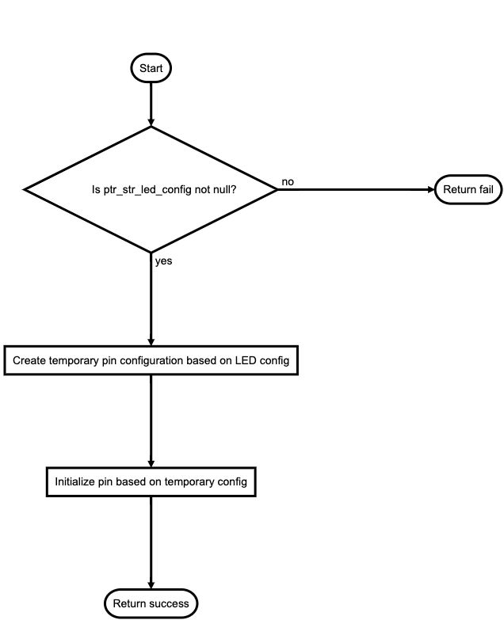

Figure led_initialization

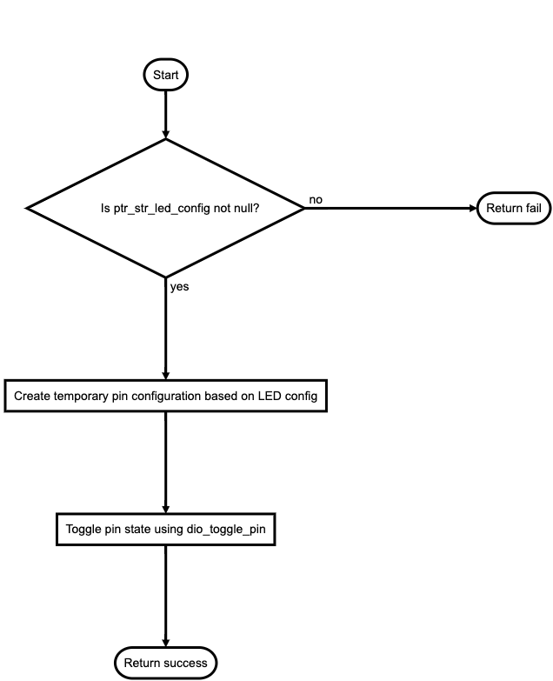

Figure led_turn_on

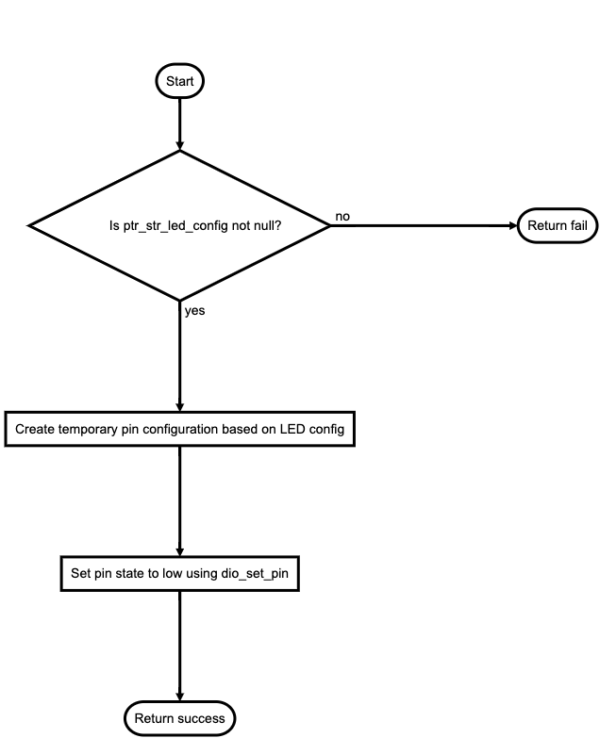

Figure led_turn_off

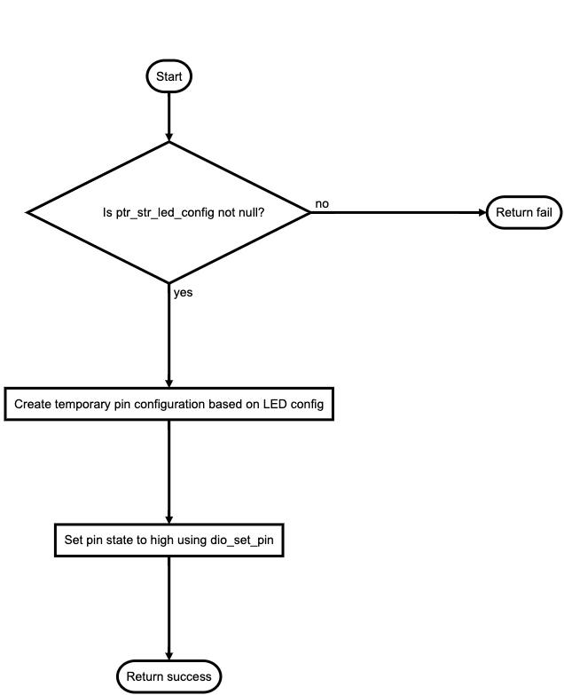

Figure led_toggle

## BUTTON

Figure button_initialization

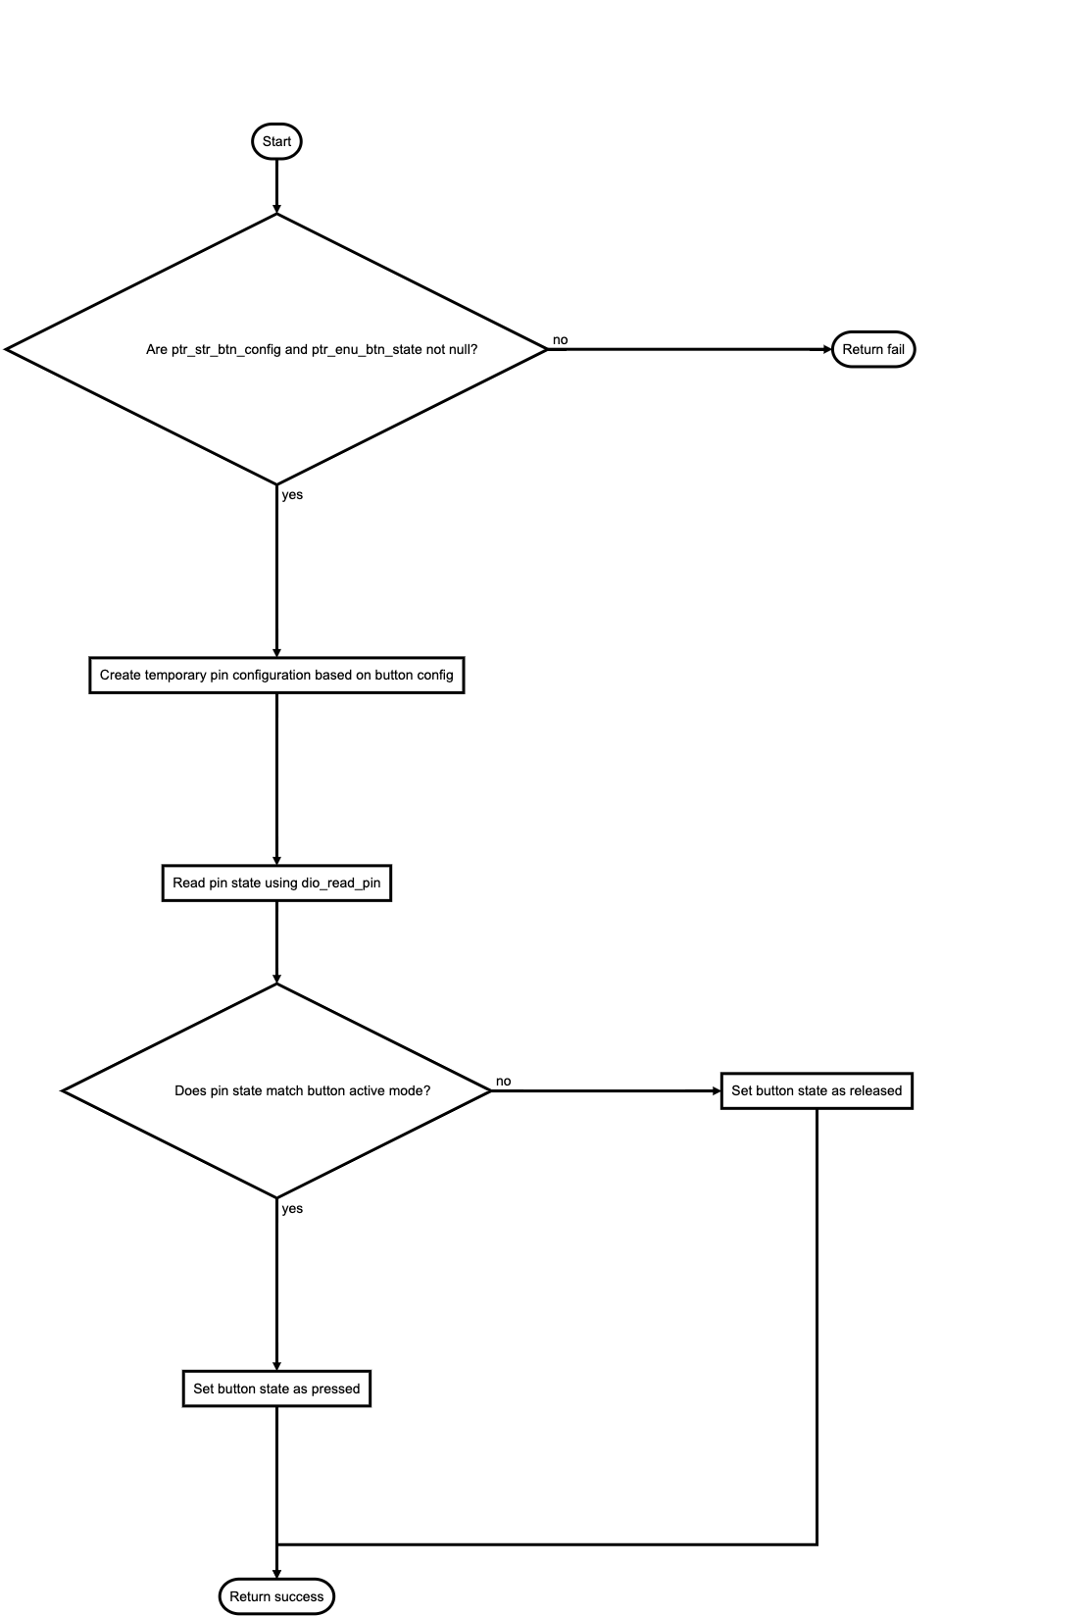

Figure button_read_state

## GPIO

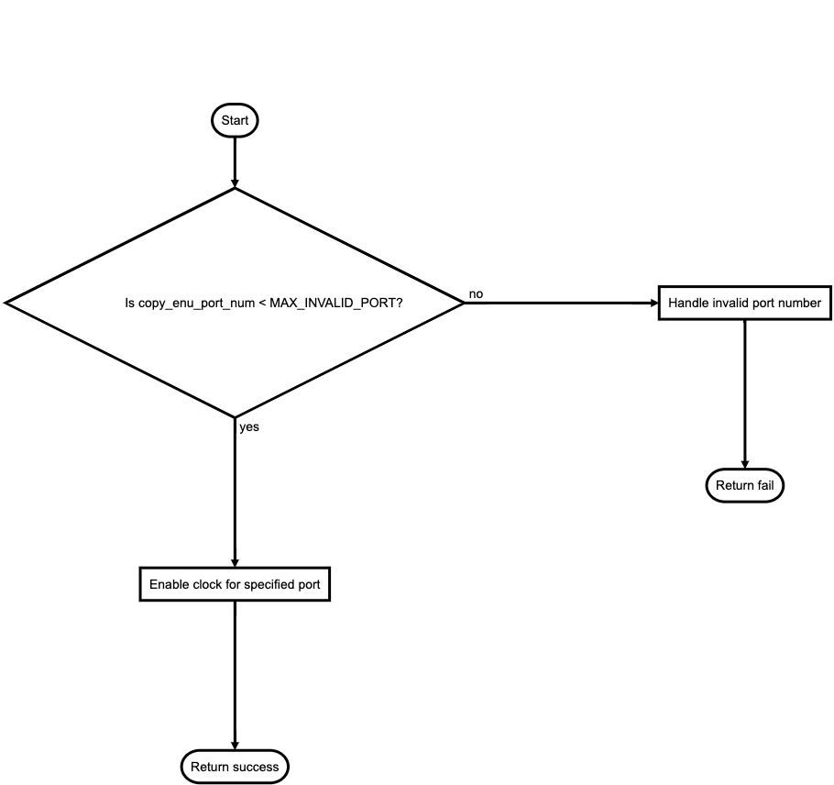

Figure dio_enable_clock

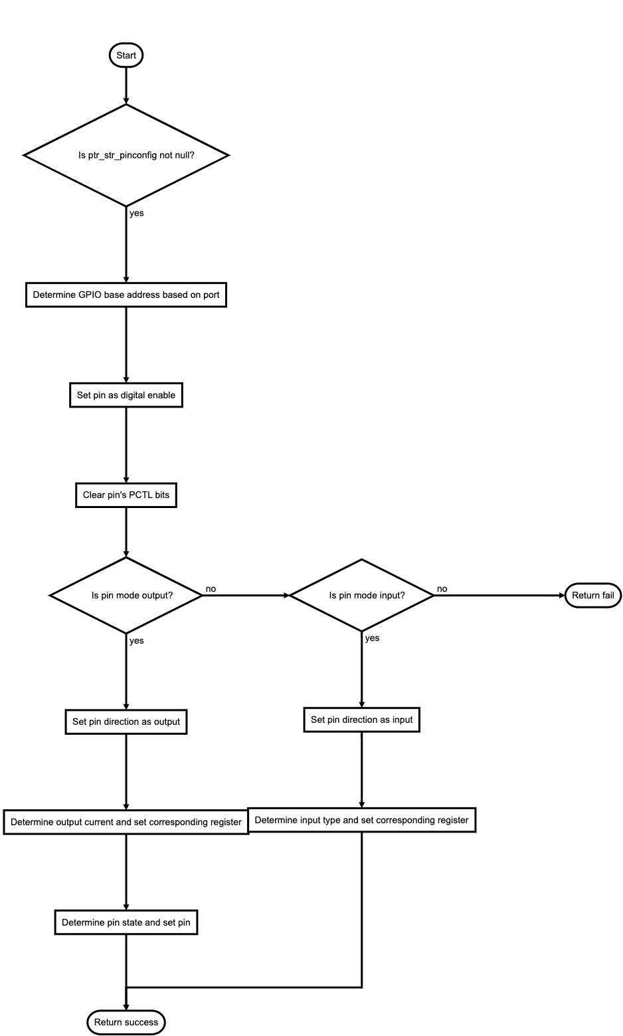

Figure dio_enable_clock

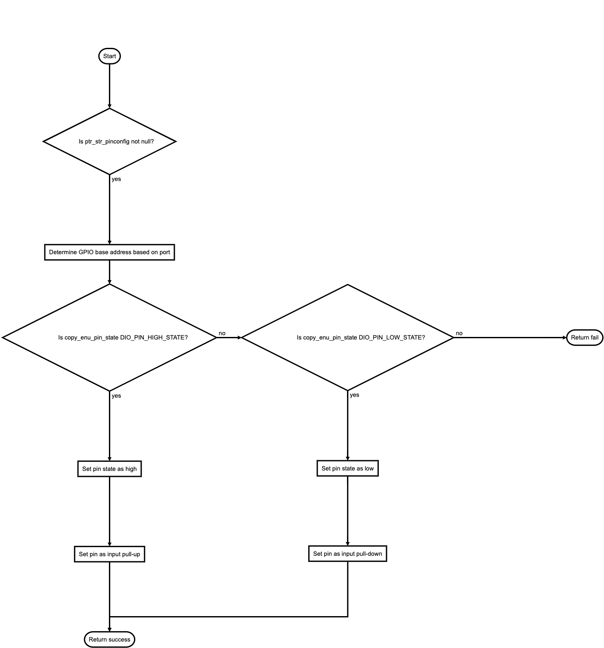

Figure dio_set_pin

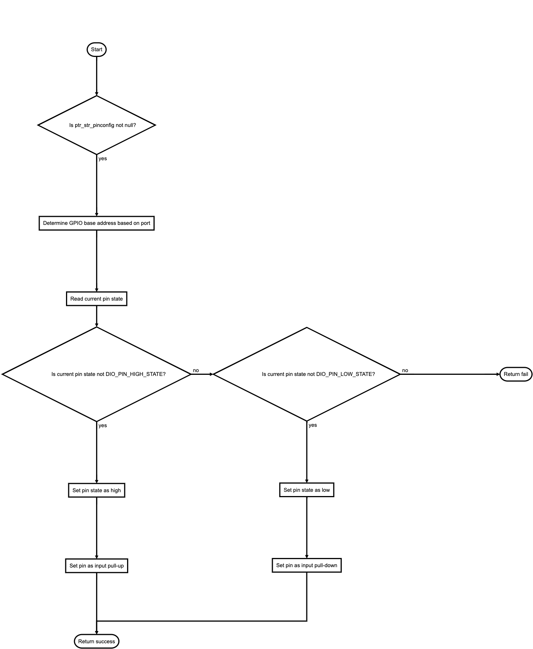

Figure dio_toggle_pin

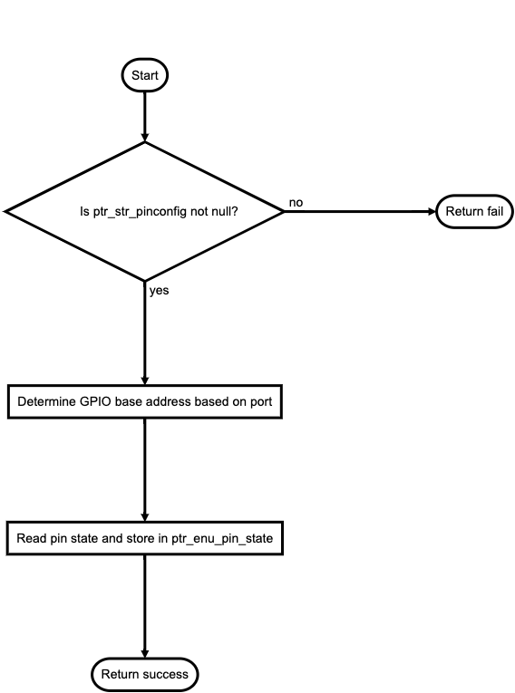

Figure dio_read_pin

## APPLICATION